12.69: a) The period of the asteroid is 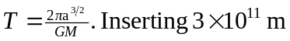 for a gives 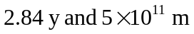gives a period of 6.11 y.

b) If the period is 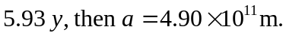
c) This happens because 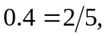 another ratio of integers. So once every 5 orbits of the asteroid and 2 orbits of Jupiter, the asteroid is at its perijove distance. Solving when 